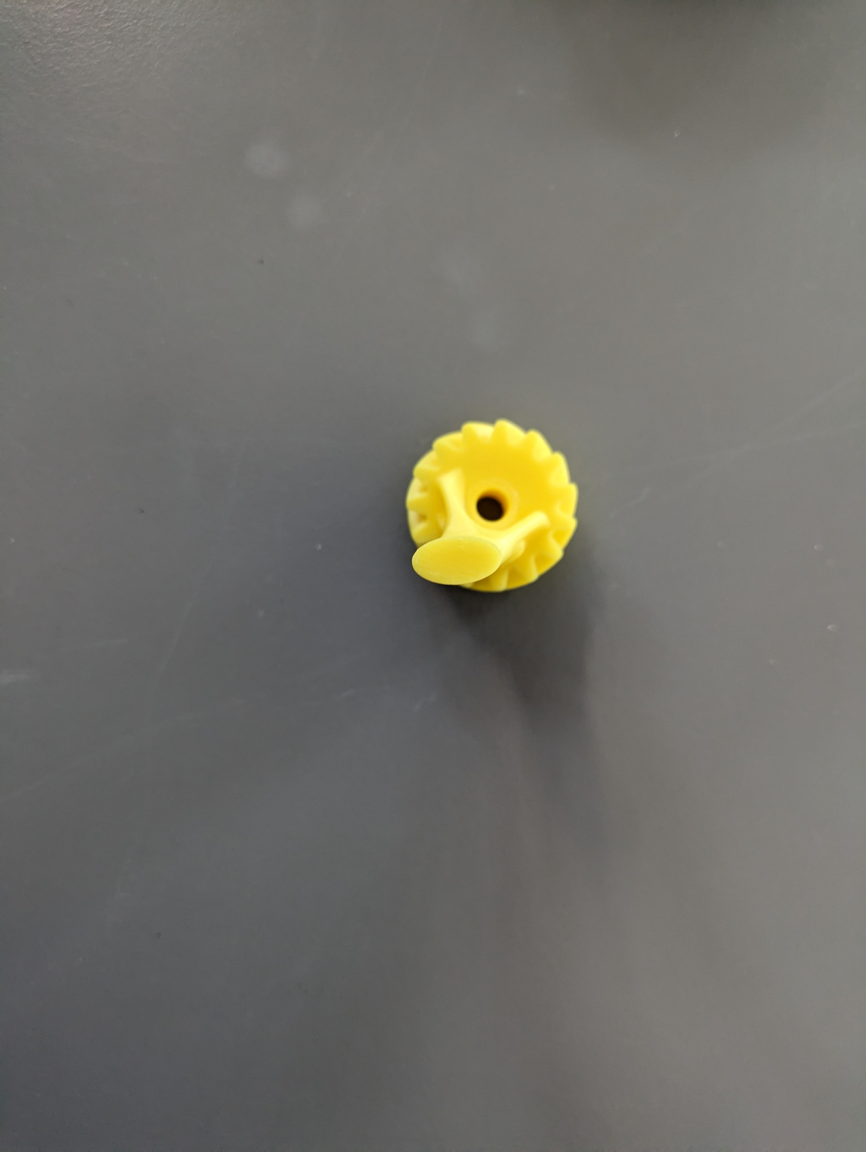Experiment to test strength of gripper finger

!!Placeholder images of an older design!!

To assess the strength of the gripper's fingers, we'll secure the bottom/gear in a fixture and apply force to the fingertip, determining the point where torque on the finger is maximized.



**4**

**Green**: Force applied & measured with dynamic force cell

**Black:** Reference line.

We will conduct four tests from different angles to evaluate various collision scenarios with the finger:

(1) Standard collision from closing on the external diameter of a checkers piece.

(2) Collision when opening, i.e., gripping the internal diameter of a part.

(3) Collision when closing, i.e., gripping an external diameter larger than a checkers piece.

(4) Collision when moving down to collect a piece.

Additionally, there is an argument to be made regarding collisions with a part in the gripper. However, these are more complex and considered beyond the scope of this analysis.

**3**

**2**

**1**